ALY 6030 - Data Warehousing & SQL - 70526  
Module 4: Alcohol Use

Professor: Valeriy Shevchenko

CPS in Informatics

Chongfan Bao

bao.c@northeastern.edu

Northeastern University

10/19/2021

**Abstract**

In project 4, I am about to endeavor to design an ERD diagram and create tables in MySQL workbench to identify expected concentrations of heavy drinking among adolescents between the ages of 18 and 24 in Oklahoma. Also, according to I created database, I will find the areas of OK have highest and lowest number of respondents for adolescent alcohol abuse by SQL query. Meanwhile, I will propose a method to identify groups of adolescents who may be at highest risk for alcohol abuse.

*Keywords:* ERD, SQL, alcohol abuse.

**Introduction**

In this module 4, I will use the heavy alcohol abuse dataset to discuss different people alcohol behavior. The dataset depicts the heavy drinker of the number of various categories of group who responded to the survey question in different county and city. My main purpose is to research the adolescence alcohol consumption who age is between 18 to 24. I will find how many interviewers participate in this survey by country and city. Furthermore, I will propose a method to identify groups of adolescents who may be at highest risk for alcohol abuse.

**Date Exploration**

After I checked the three tables, I found that only Oklahoma state has interviewers’ sample data. As other states as well as the District of Columbia and three U.S. territories, there is not any sample dataset. It only has the county, city and zip code three attributes. In addition, the question and answer are same. All people are heavy drinker. The values in column 'Data_Value' are in decimals. This is because some people are not 100% heavy drinkers, therefore approximation number is used, which is decimal, not exact integer one.

As the Microsoft Excel Pivot table 1, we can notice that there are seven classes and several sub-classes. Each category displays the number of sample size. There are total 667 records. Meanwhile, we also find some null value. In order to keep the data consistency, we will keep this null value in my database.

However, based on the requirements of assignment, I just need to explore the group that age is between 18 and 24. They belong to adolescence. In the future, we could discuss more category and we also need to more data information, such as the gender difference in alcohol abuse or race and ethnicity or education attained and so on.

If we want to find methods to identify groups of adolescents who may be at highest risk for alcohol abuse based on this dataset, as far as I am consider, it is far not enough. First of all, people addict with alcohol that can cause by many reasons such as pressure, the alcohol addiction of parents of friends, the environment at that moment and so on. We need to research if they own and relatives have the alcohol addiction history, if they were drunk or like drink when they happy or sad. Also, the frequency is an important index to evaluate if adolesces is alcohol index.

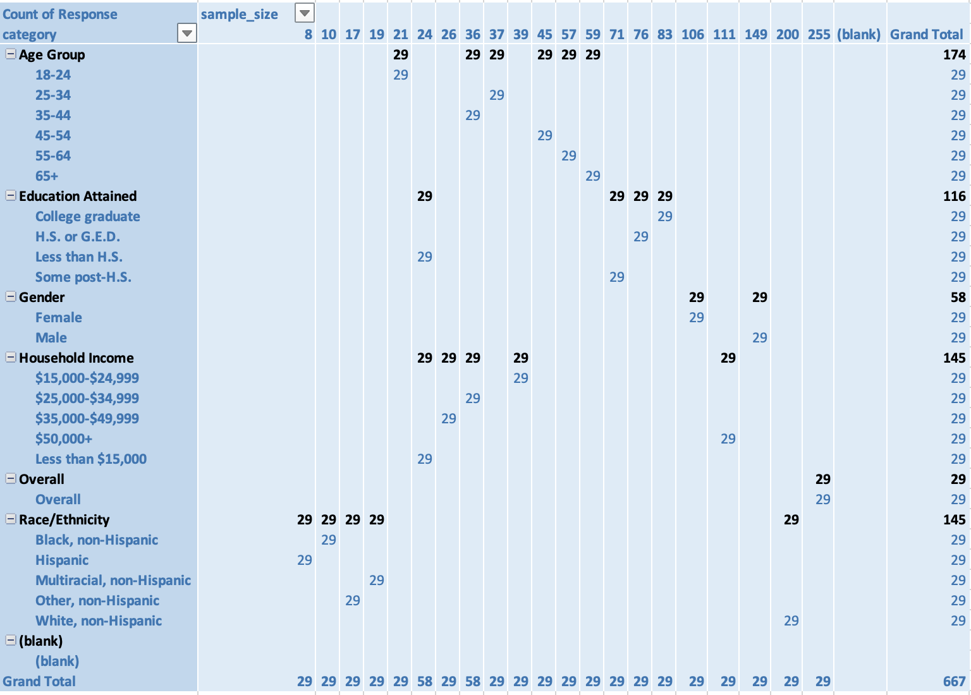

Table 1

**Modeling**

I will create a database and several tables by MySQL workwench. As figure 1, I create five tables in a named week 4 database to store the original three tables dataset. However, as I noticed, there are many repeated data in the files. So, in order to reduce data redundance and fulfill data normalization rule. I consider that the question table is filled by question column, the answer table is filled by answer column, the category table is filled by “Break_Out_Category” and “Break_Out” two columns, the statistic table is filled by the sample size and date size column, the location table is filled by county, city, zip code column. All table details will show in the appendix.

Furthermore, I try the statistic table to connect with other tables, so I manually add some IDs as primary key or foreign key for each table. This is also help us build ERD diagram and use SQL query referring to different table.

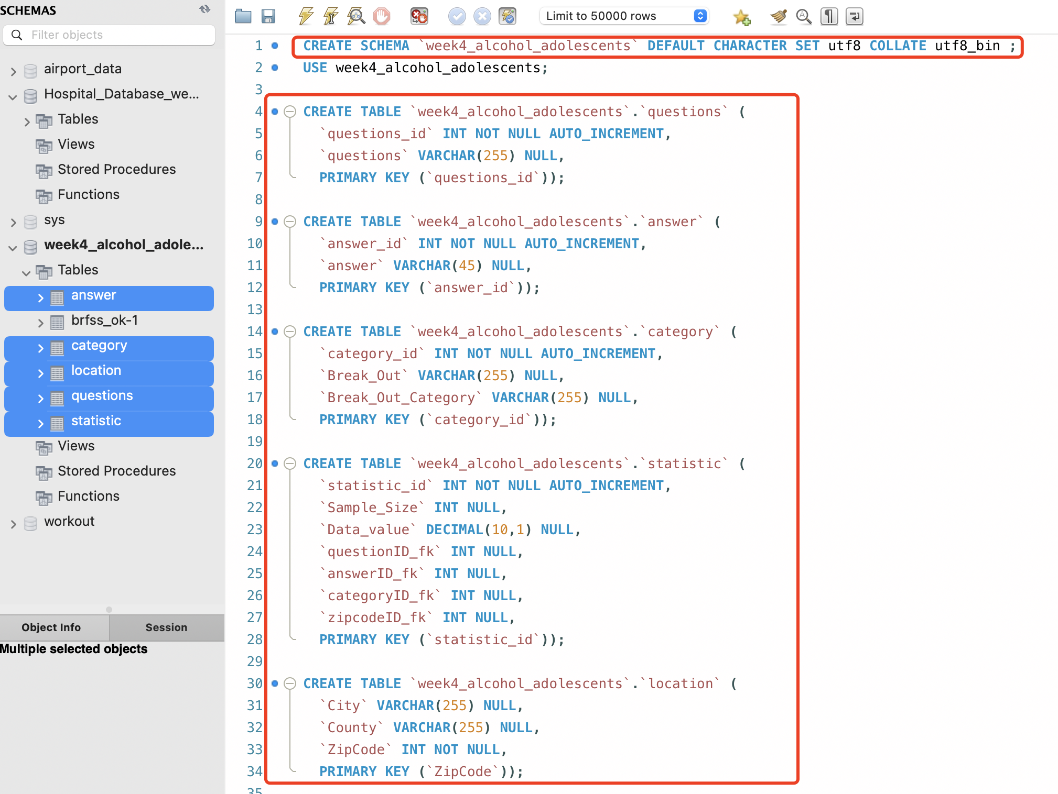

Figure 1

Now, I will set foreign key in MySQL workbench so that table can truly connect. As the figure 2, I totally set four foreign keys and refer to different table, Also, I add some contracts for the table.

Figure 2

In order to the unique of the category, I will set up the “break_out” and “break_out_category” as a combine attribute in indexes interface. This can avoid a duplicate value input and import mistakes by system. Showed in figure 3:

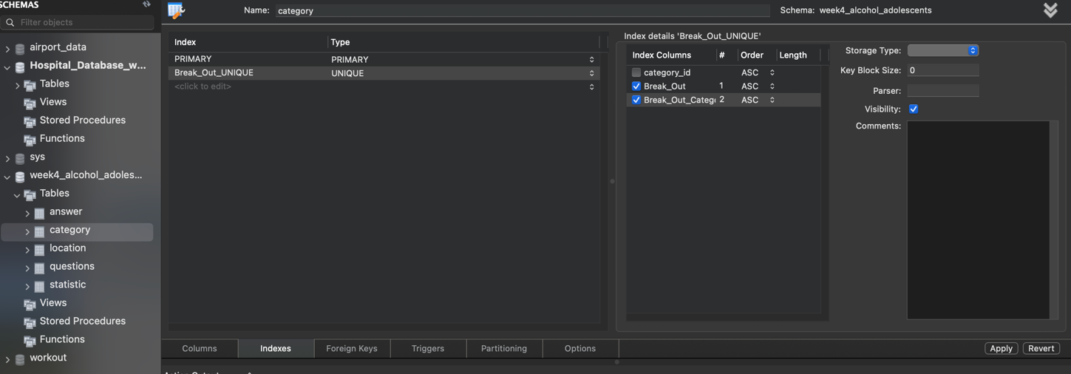

Figure 3

After we set the relationship between the tables, I can export the ERD diagram quickly as the figure 4, which also display the relationship of table.

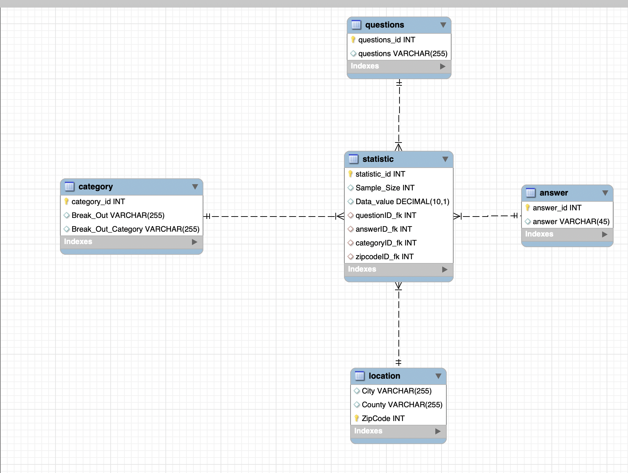

Figure 4

**Data Import and Analysis**

Due to various system error pop out, I decide to import an original dataset into the database. Then, I will select the data import into the table that I created.

As figure 5, I choose the file path by MySQL workbench to import data.

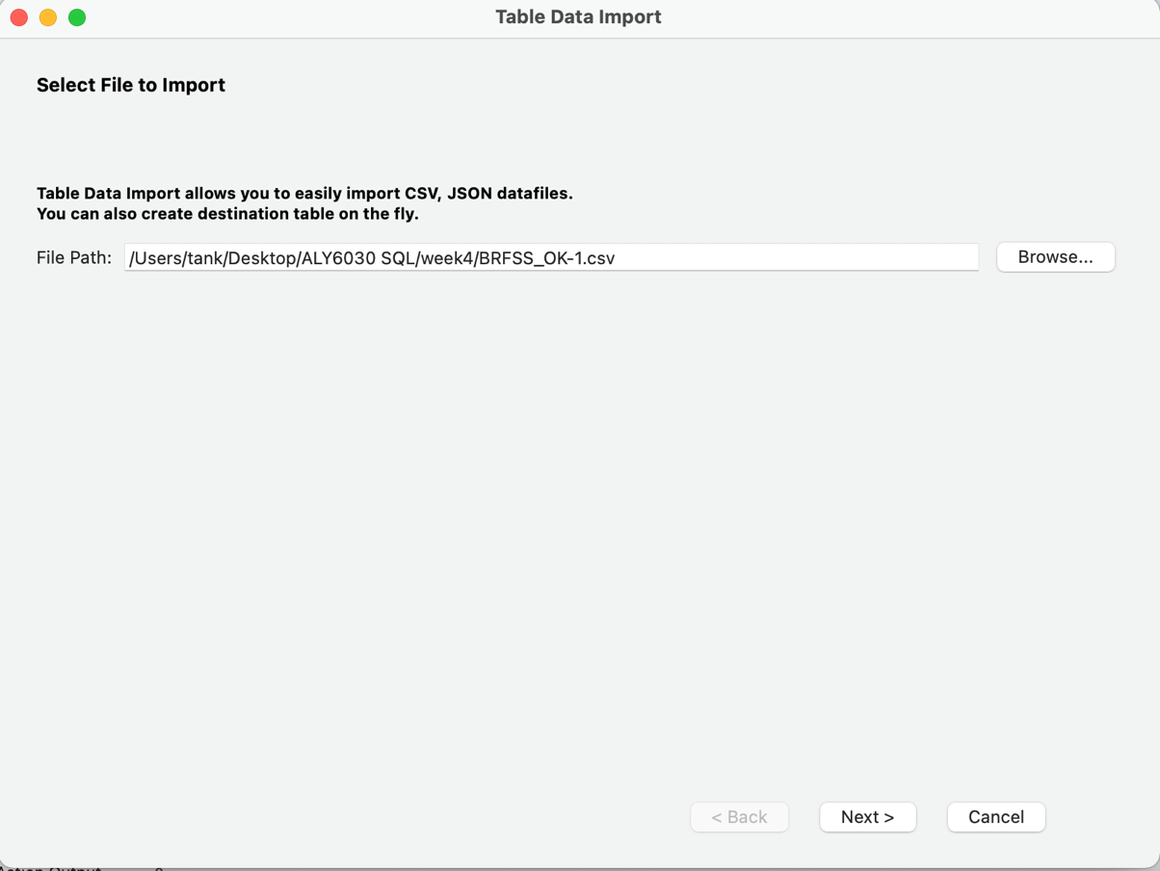

Figure 5

As figure 6, I choose to create a new table in the database so that it can be same as the original table and use it to import data to another table.

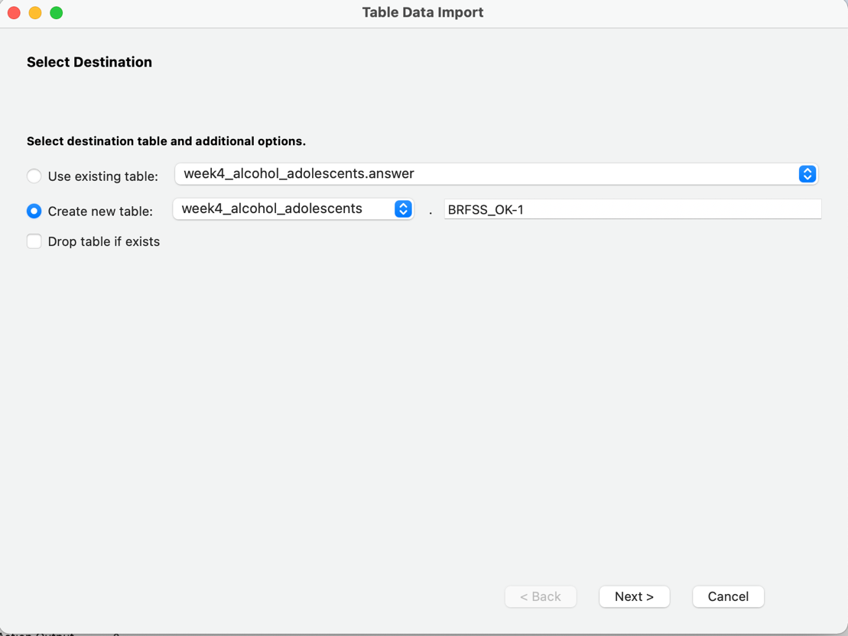

Figure 6

As figure 7, I select all the column to import and use the utf-8 format. Also, I set the attributes of attributes as default.

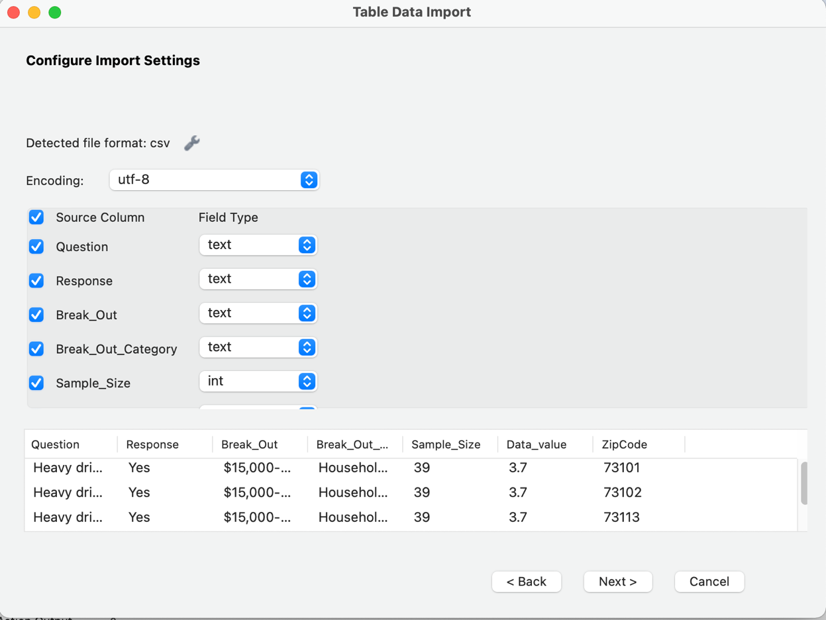

Figure 7

From figure 8, it shows the import is successful.

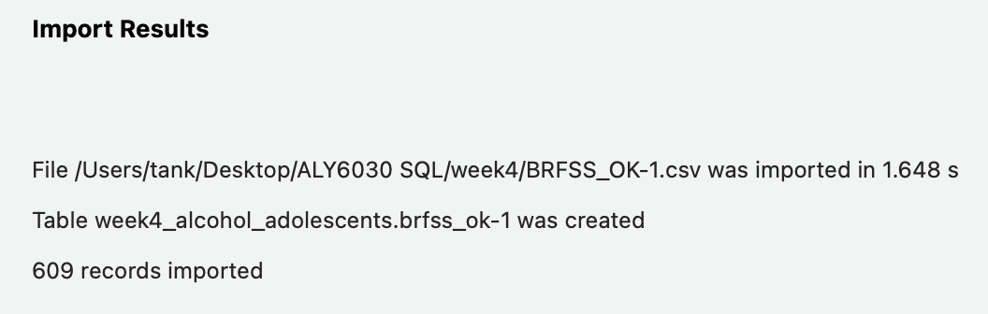

Figure 8

Now, I will use the SQL syntax import data into answer table, question table, category table and statistic table. The code as followed figure 9. All results are displayed in Appendix. I use code because these table have the repeat values, so we don’t need to import each time. And it also break the data normalization rule and cause data redundancy.

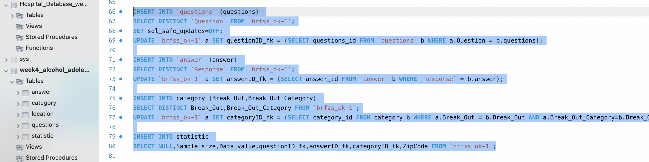

Figure 9

Then, I will import last location table by table import wizard function in MySQL workbench.

Choose the file path in figure 10.

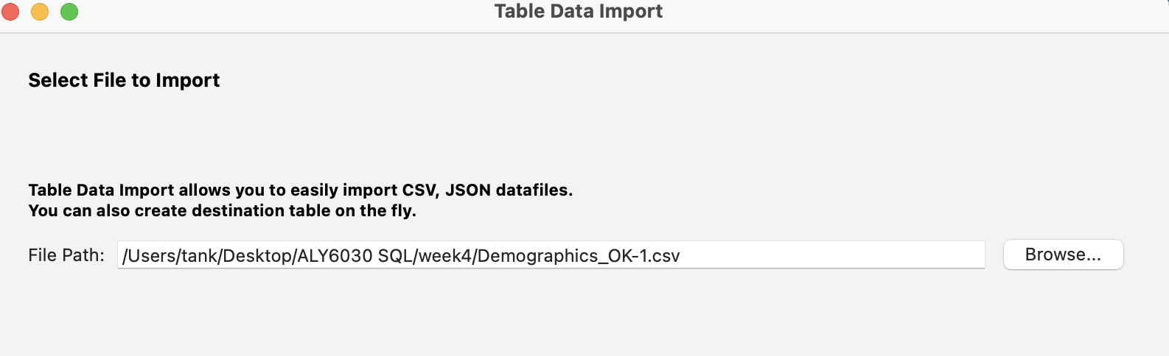

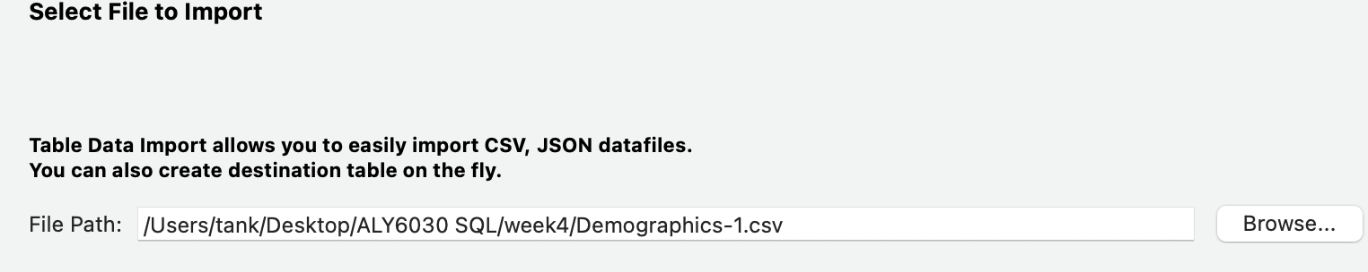

Figure 10

Choose the destination table and import in figure 11. Keep this in mind, when we import second table data, we shouldn’t choose the truncate table before import.

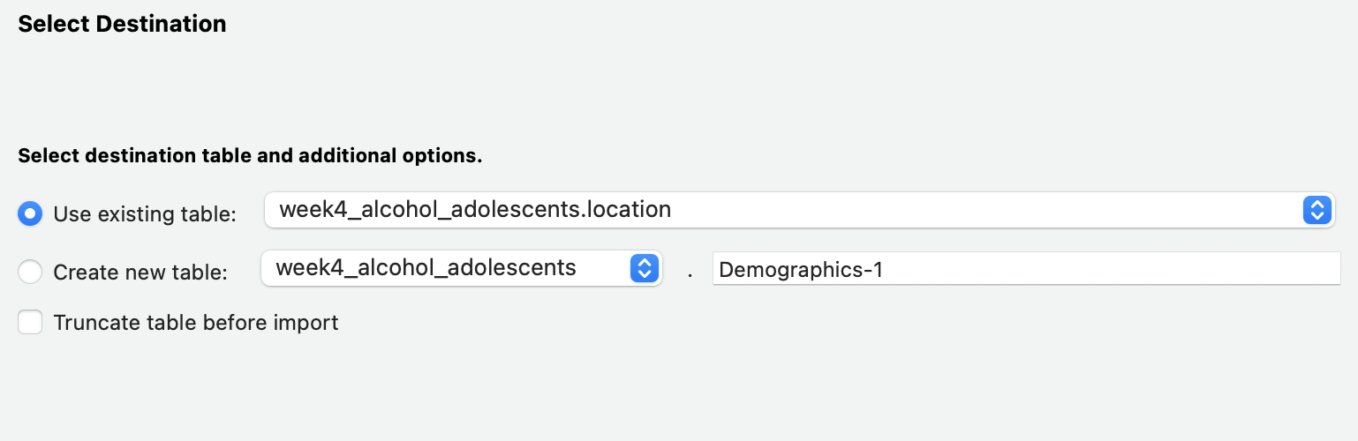

Figure 11

As figure 12, I select all the column to import and use the utf-8 format. Also, I set the attributes of attributes as default.

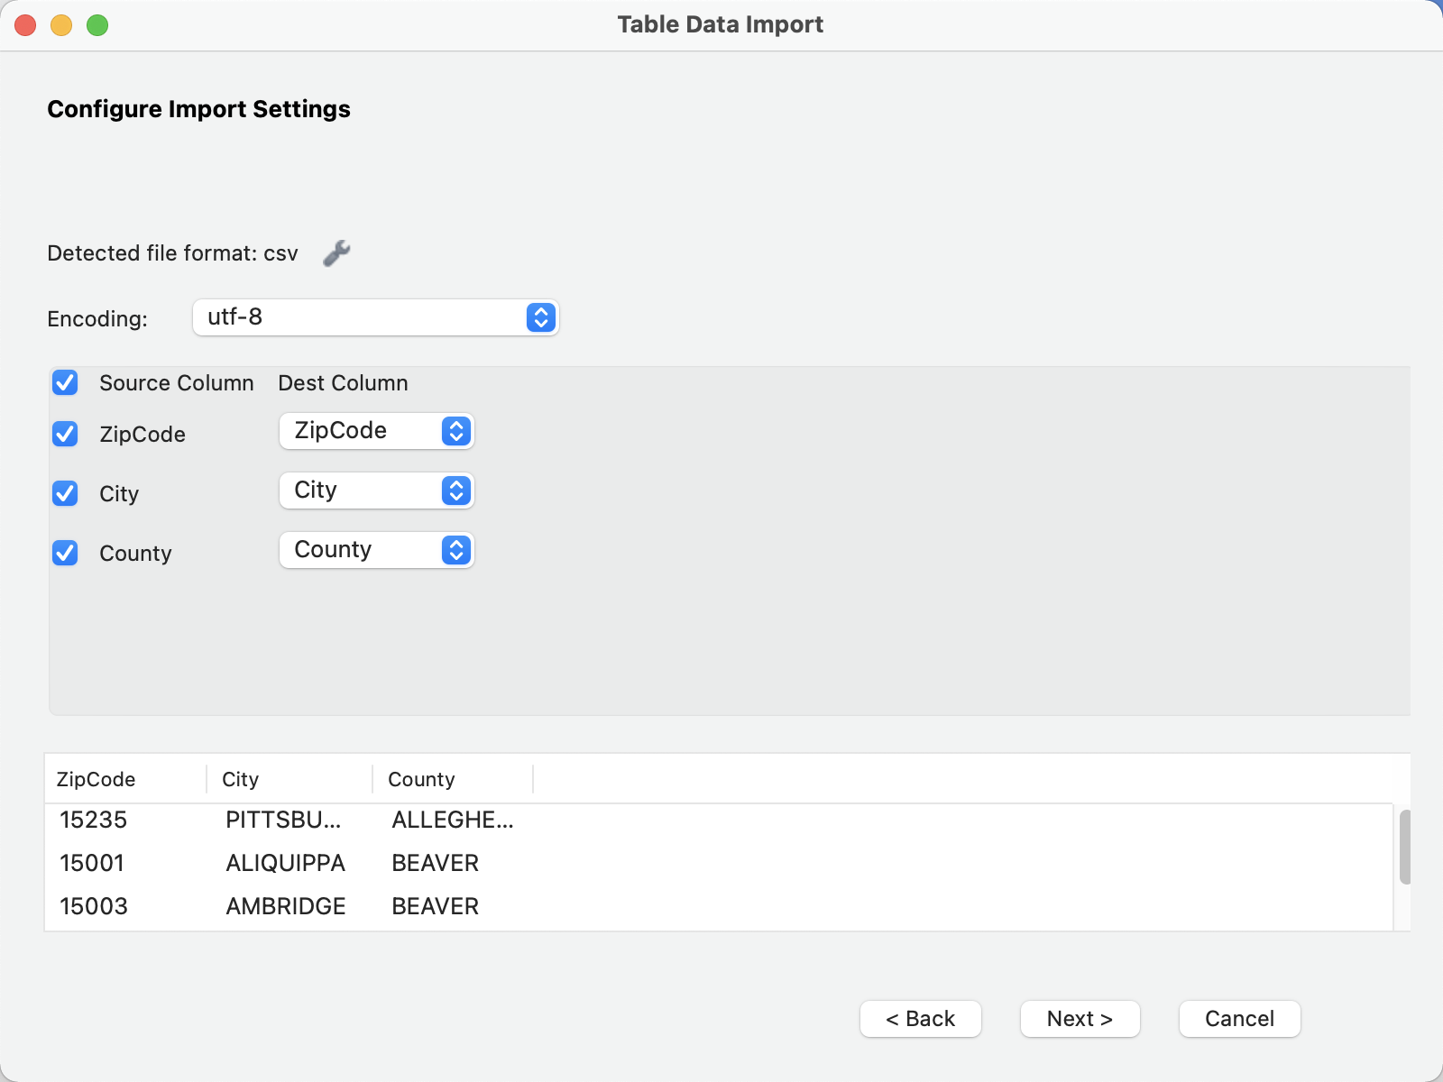

Figure 12

From figure 13, it shows the import is successful.

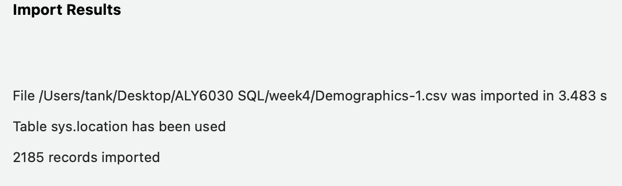

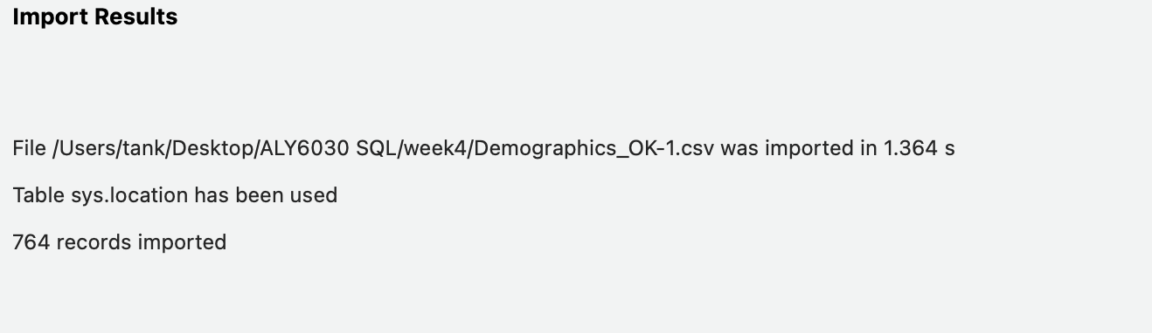

Figure 13

I need to query the adolescent’s alcohol abuse in the state of Oklahoma by SQL syntax. Figure 14 shows that there are the 24 people who were asked the question, and 6.2 people who responded to have the issue with heavy drinker. They all come from the Oklahoma city.

Figure 15 also shows that there are the 24 people who were asked the question, and 6.2 people who responded to have the issue with heavy drinker, but they come from the Oklahoma and Cleveland.

Based on the dataset, I find an interesting thing is that there is not any highest and lowest number of respondents for adolescent alcohol abuse. All are same sample size and data value. Only the zip code has huge difference. So, we need more information to get into the insight about people who are between 18 and 24.

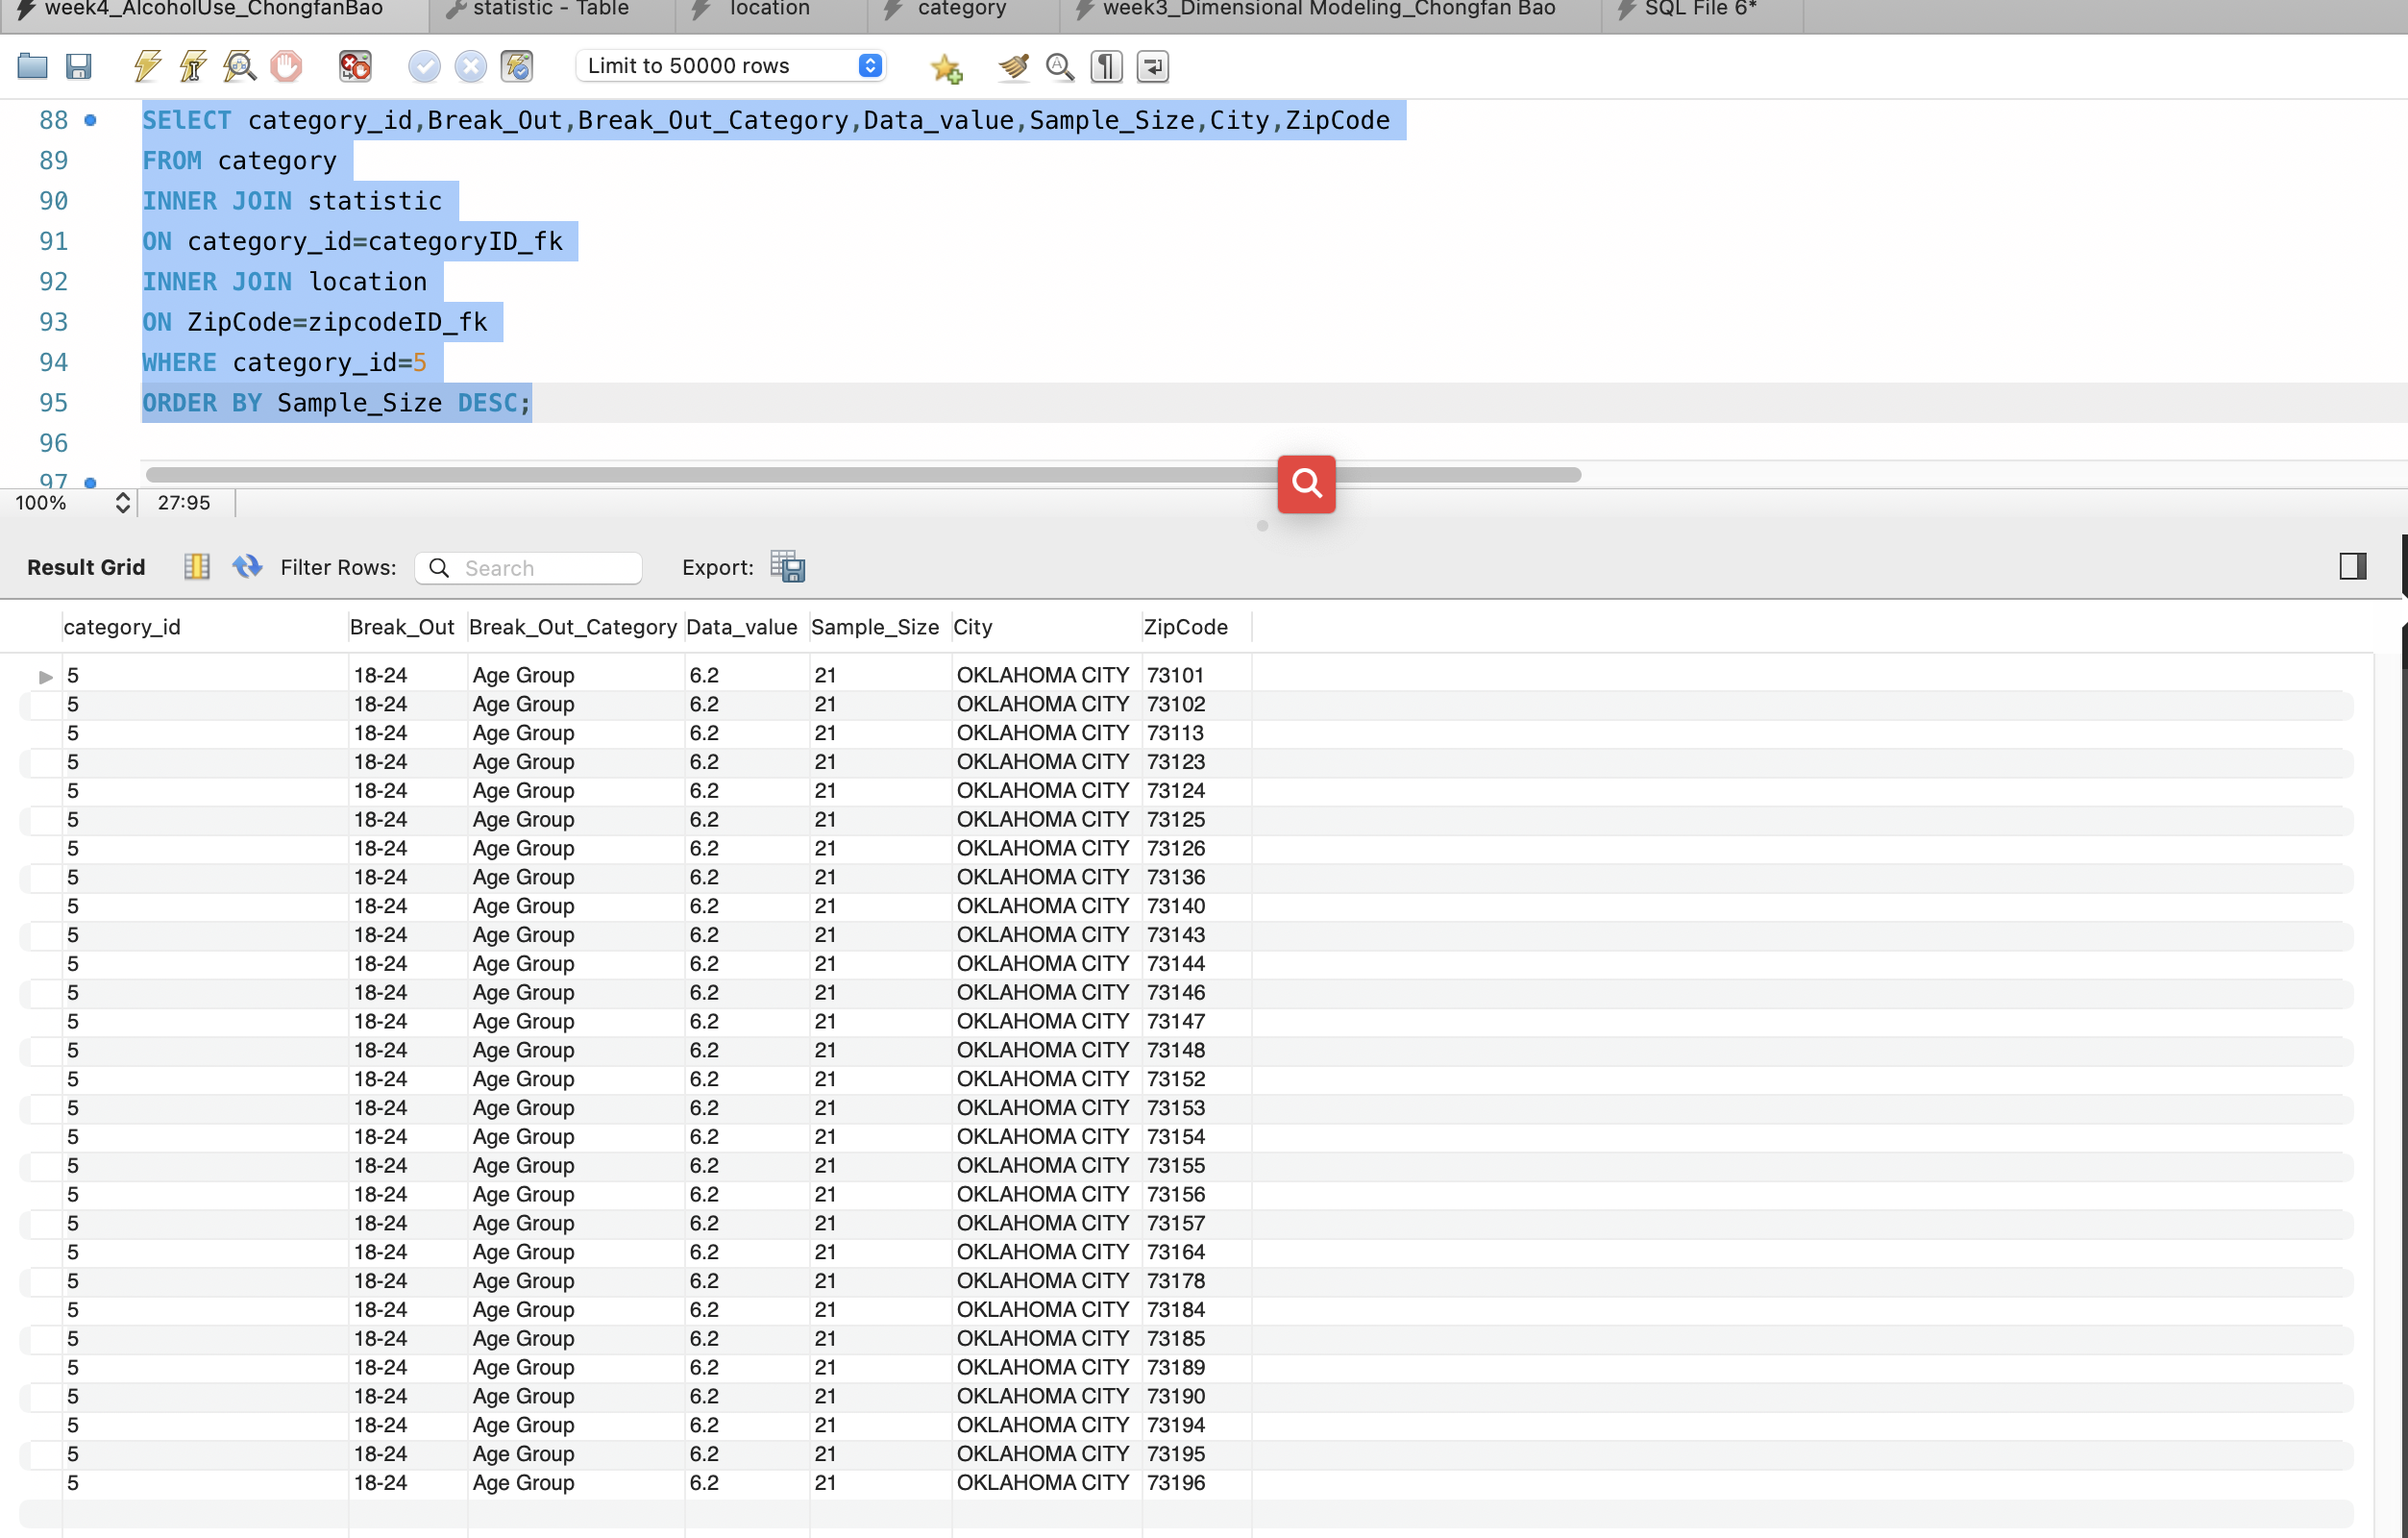

Figure 14

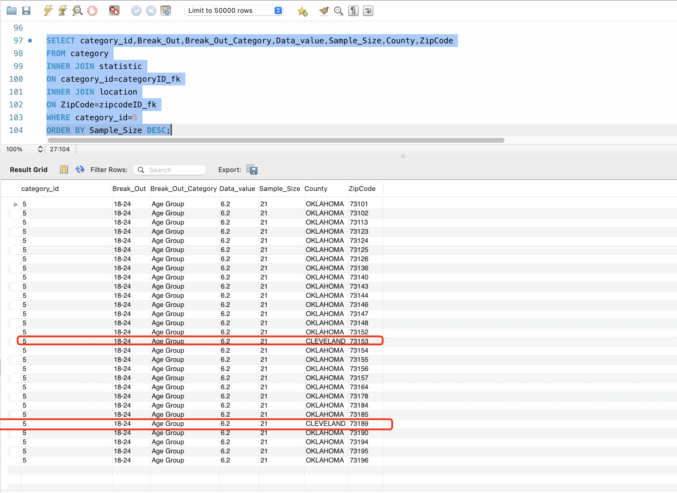

**Conclusion**

In the whole project, I drew ERD and created database and tables. Then, I used the SQL syntax to query the adolescent’s alcohol abuse in the state of Oklahoma. However, I find that there is not any difference between the highest and lowest number of respondents for adolescent alcohol abuse. There are 24 people who were asked the question, and 6.2 people who responded to have the issue with heavy drinker.

By this project, the biggest challenge is that I don’t know how to make other tables’ ID that I create have the same ID series in the statistic table. And the same value should have same ID. I also meet file format problems. Luckily, under my friends help, I know how to ensure each ID unique and import a correct format file. I can use unique function and set function to make sure that even if we don’t have WHERE condition, we still can import data. In the fugure, I believe that I will be able to use MySQL professionally to solve any business questions.

**Appendix**

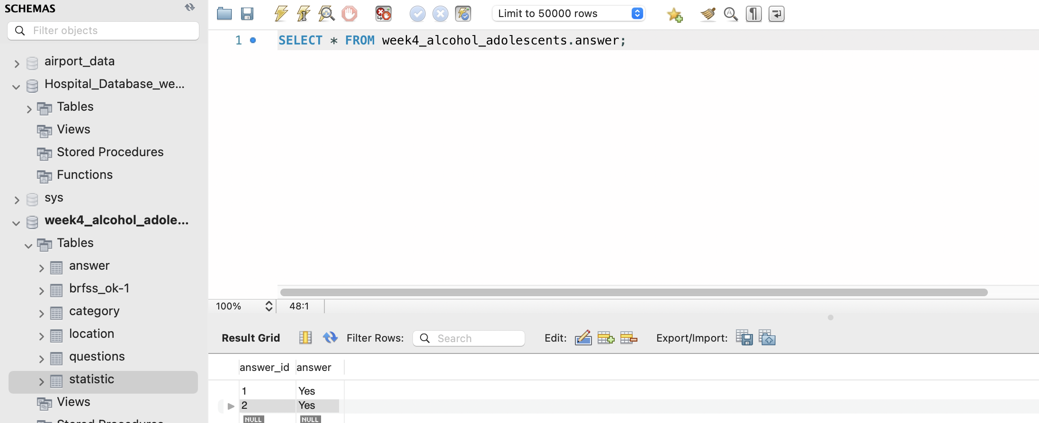

Figure 1

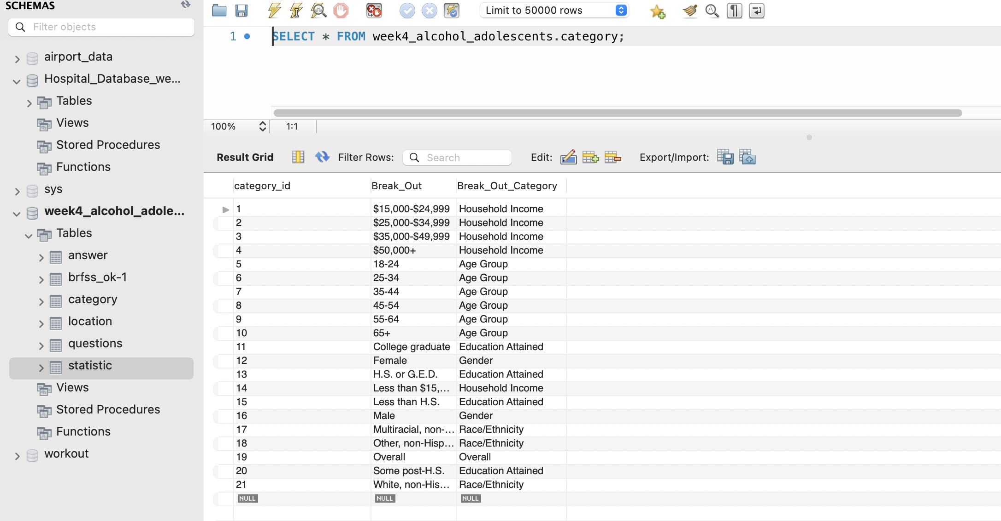

Figure 2

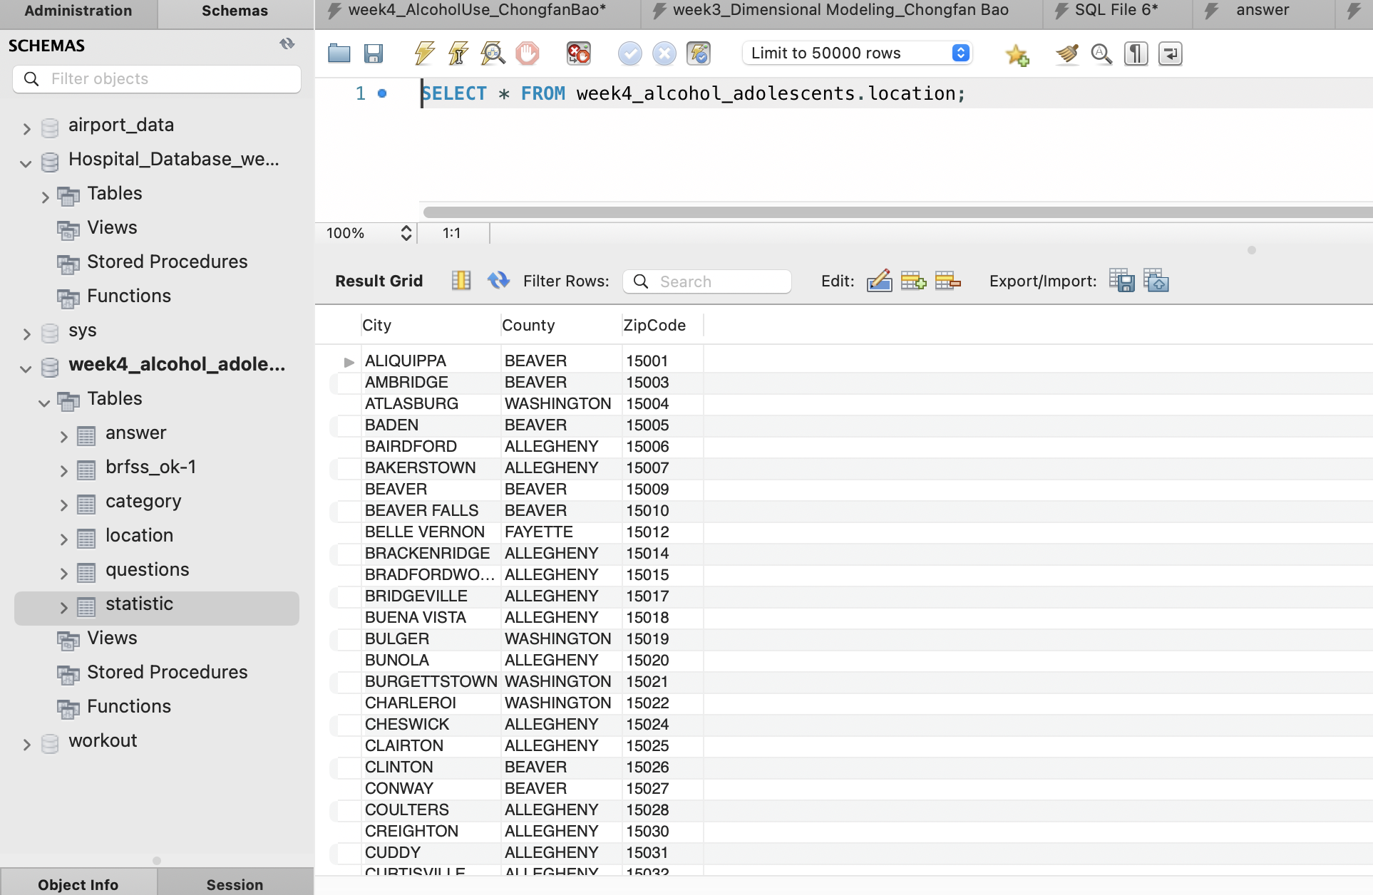

Figure 3

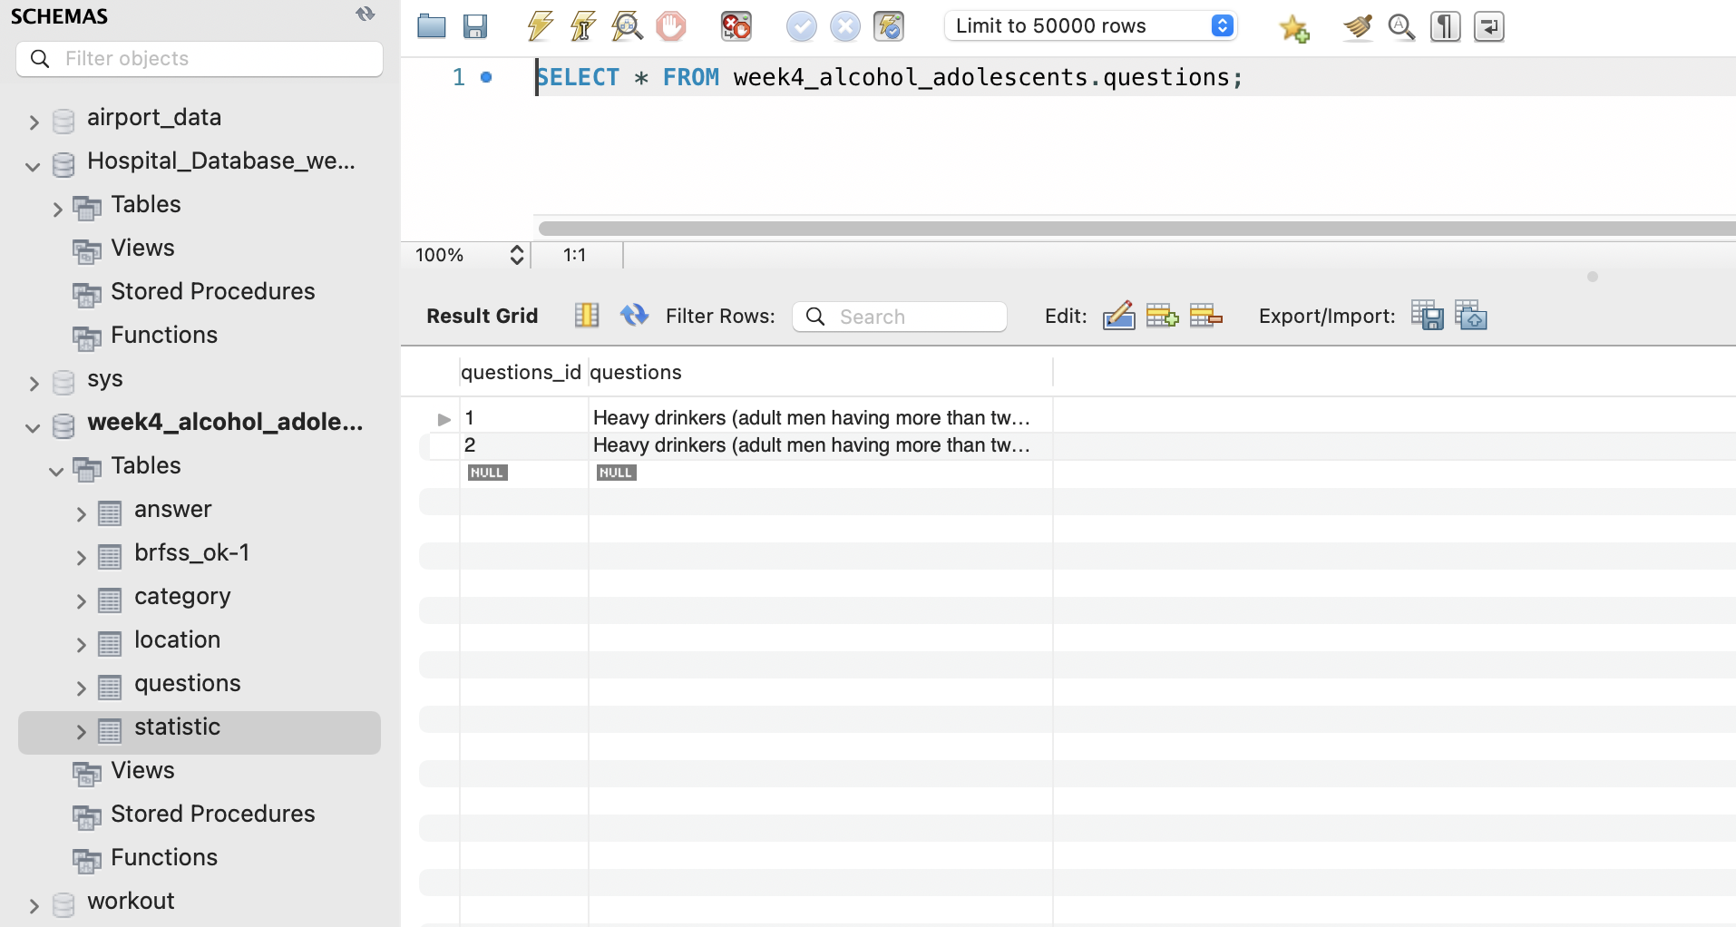

Figure 4

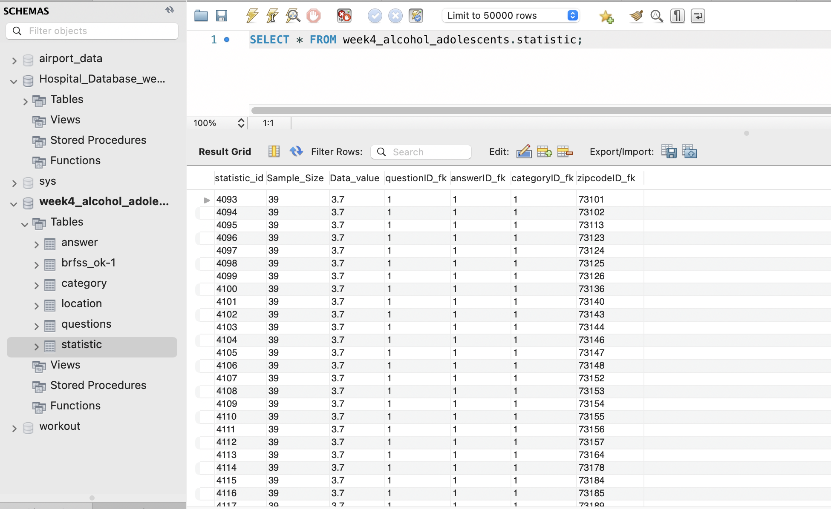

Figure 5